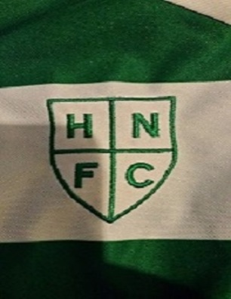
HOLY NAME FOOTBALL CLUB
IS LOOKING FOR NEW TALENT
We are looking for players for the under 17’s
for the season starting
September 2019
Come and Join a Club who can offer;
GREAT EXPERIENCED FA QUALIFIED COACHING
A FRIENDLY & FUN TRAINING ENVIRONMENT
THE CHANCE TO BE PART OF A PROGRESSIVE CLUB
IF YOU WISH TO TRY OUT THEN COME TO OUR Training Sessions
Every Saturday from 12.00pm
Red House Park, Great Barr

Contact Wayne Smart on 07920 026721 if you would be interested.

HOLY NAME FOOTBALL CLUB IS AN FA CHARTERED STANDARD CLUB.

